**Component Products Management**

* This document outlines the setup and workflows for managing component products using the newly created location "Component-Output".

## **Setup: New Location**

* **Location Name:** Component-Output
* **Purpose:** To manage a stock of component products separate from other products.

## **Workflow for Purchase Orders**

* + To ensure that component products purchased are received directly at WH/Stock rather than the default receipt location, follow these steps:

### **Steps:**

* + - If you are creating a purchase for fabric products from a file:
      * You have to select the "Deliver To" field from here as shown below.
      * For fabric product purchase select the "Deliver To" field as **“My Company: Receipts”**

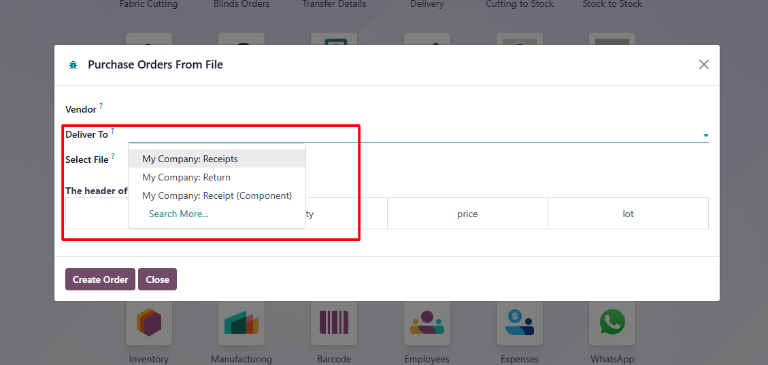

* **If you are creating a purchase from the direct purchase menu:**
  + **It’s compulsory to create a purchase of components directly from the purchase menu, not using an Excel file.**
    - When creating a purchase order for component products, set the "Deliver To" field as **“My Company: Receipts (Component)”**

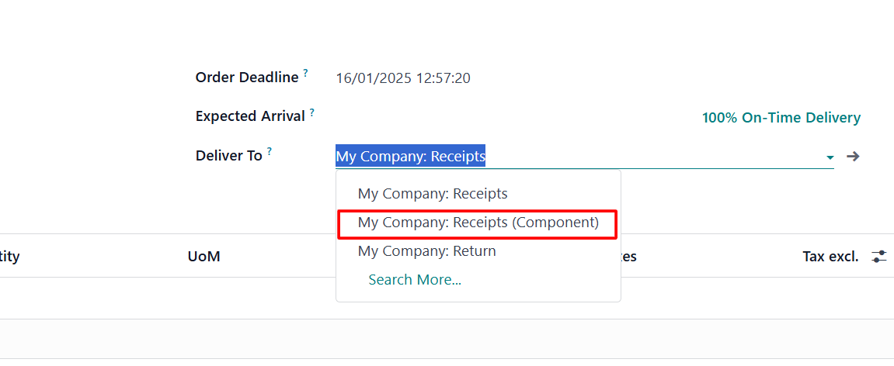

## **For packages of component products in receipt**

* + To create packages for component products, you can import an Excel file using the **Import Picking Lines** feature.

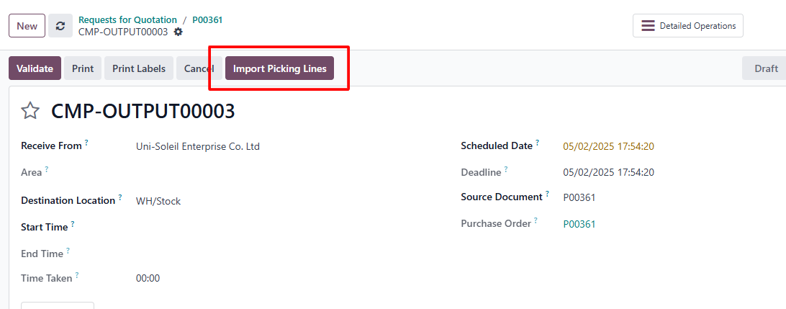

* Ensure the header of the purchase file is formatted correctly, as shown below:

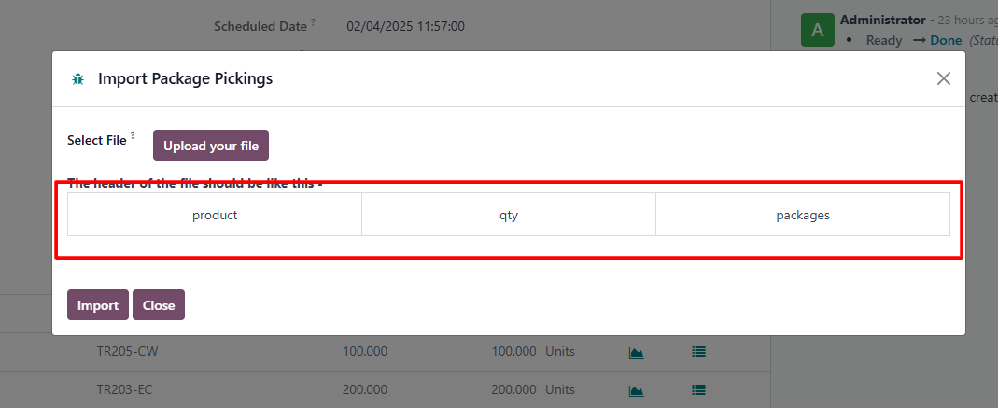

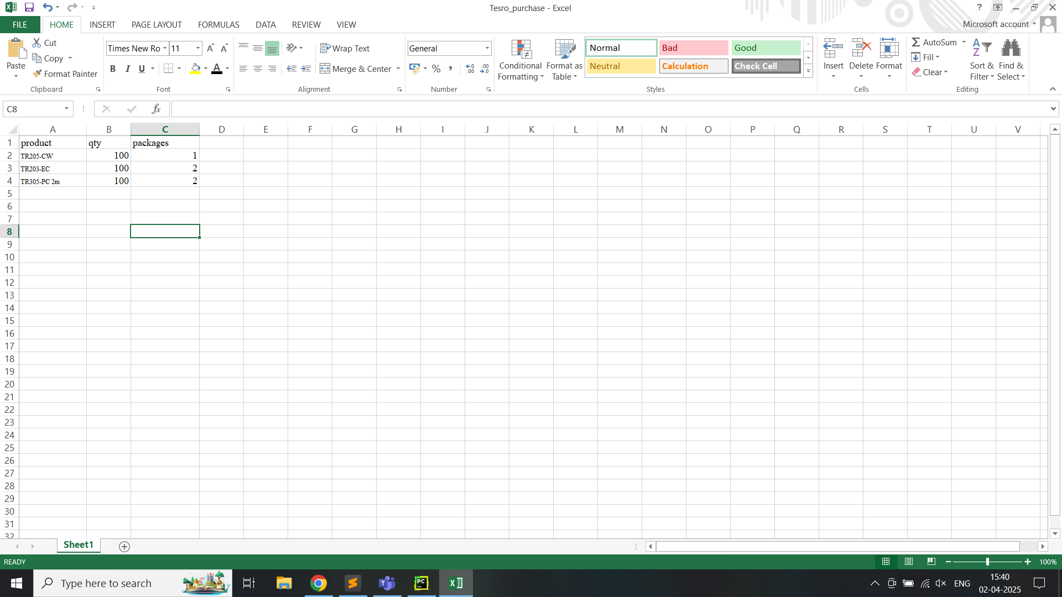

* Navigate to the import section and upload the prepared Excel file.
* Upon successful import, the system will automatically generate the required packages.

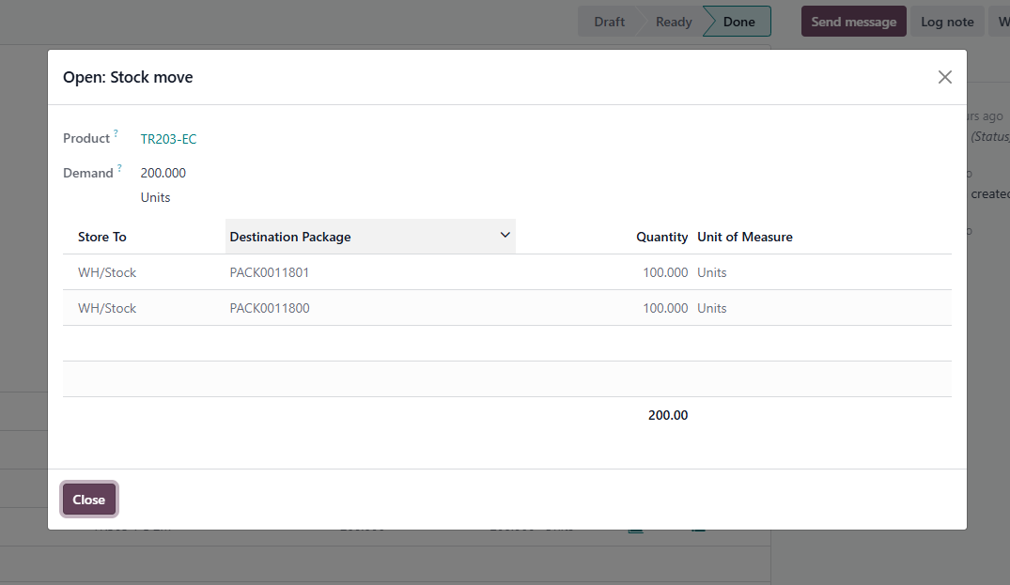

* Once the receipt is validated, the component products will be transferred to the **WH/Stock** location.
* After that, Component products can be transferred manually from the **WH/Stock** location to the **Component-Output** location.

## **Workflow for Sales Orders**

* + Ensure that component products are sold from the **Component-Output** location.
  + The system will automatically source component products from **Component-Output**. If component products are not available at this location, a warning will be raised to notify the user about the stock shortage at **Component-Output**.

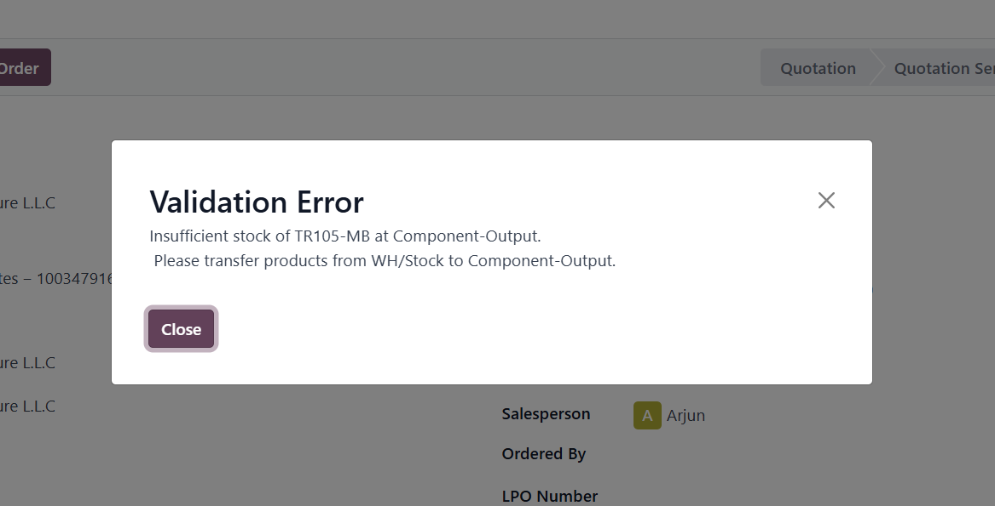

## **Workflow for Internal Transfers**

* + Component products must be transferred manually from the **WH/Stock** location to the **Component-Output** location.
    - **Source Location:** WH/Stock
    - **Destination Location:** Component-Output
  + Once the stock has been successfully transferred to Component-Output, confirm the sale order to proceed with the fulfillment process.
  + We created a new operation type specifically for this purpose to make it easier to transfer component products from **WH/Stock** to **Component-Output**.

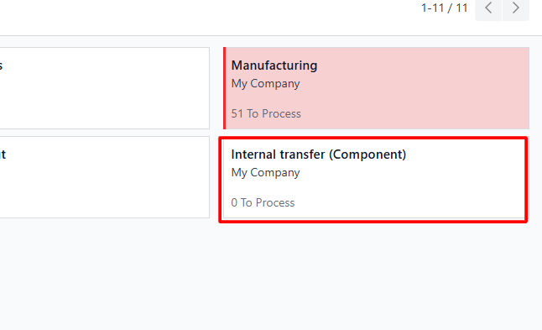

* Use the barcode scanner to scan the package.
* Ensure that all necessary packages are included in the transfer.
* Validate the transfer to move the entire package from **WH/Stock** to **Component-Output**.

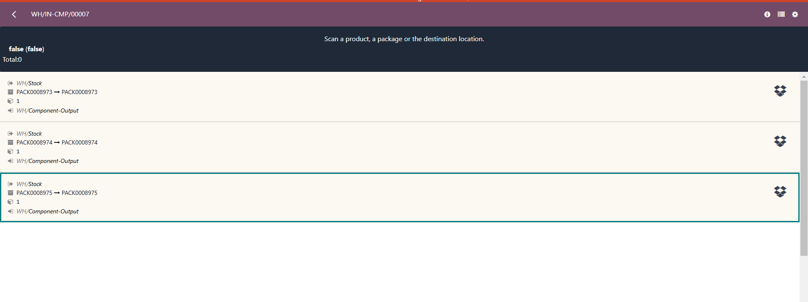

## **Workflow for Manufacturing Orders**

* + For manufacturing orders, the **Component-Output** location will be used as the source of raw materials.
  + The components required for the manufacturing order should be sourced from **Component-Output**. If not available, the system will trigger a warning for stock procurement when a blind order or track order is assigned.
  + For that, components must be transferred from **WH/Stock** to **Component-Output** (via internal transfer).
  + **Blind Orders for Manufacturing**:
    - For manufacturing orders involving **blind fabric**, the fabric will be sourced from the **WH/Output** location rather than the **Component-Output** location.
  + Once the components (from **Component-Output**) and blind fabric (from **WH/Output**) are available, the manufacturing order can be processed.

## **Workflow for return products**

* + All return products should be returned at **WH/Output** location.
  + From **WH/Output**, products can be manually relocated to their appropriate stock locations based on specific needs.

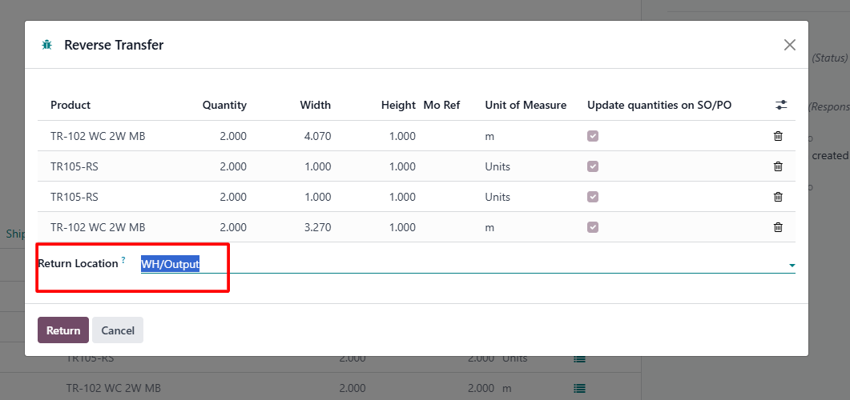

* To transfer the return component products manually from WH/Output to WH/Component-Output, go to the **Inventory Adjustments** and apply the filter of product type and WH/Output location as shown below.

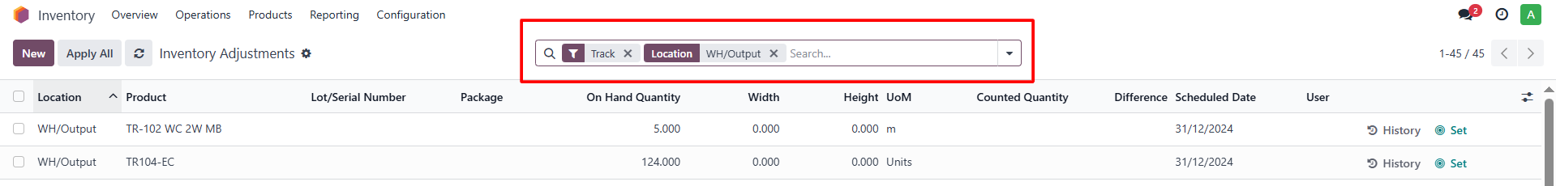

* Then select the component products that you want to relocate from the WH/Output to the WH/Component-Output location and apply the relocation.

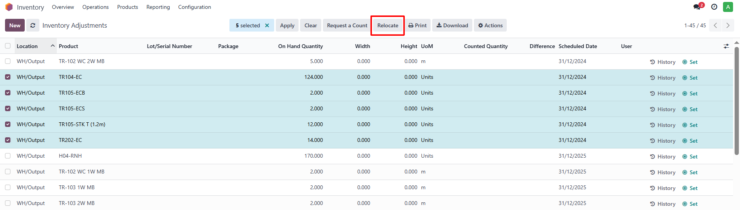

* Select the location WH/Component-Output and do the relocation.

